II
1.
Project 1
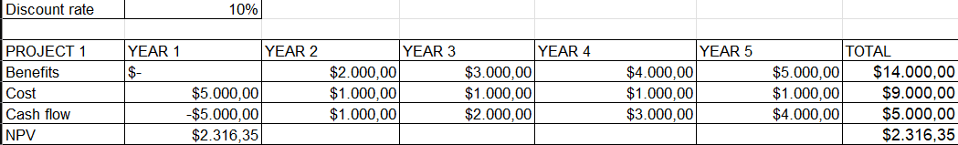
Project 2
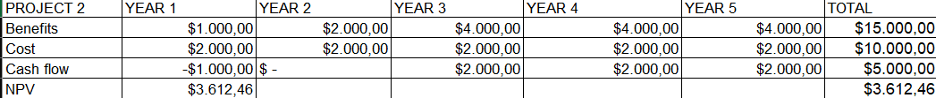
NPV Project 2 > Project 1 ($3612 > $2316) => Chọn Project 2\
2.
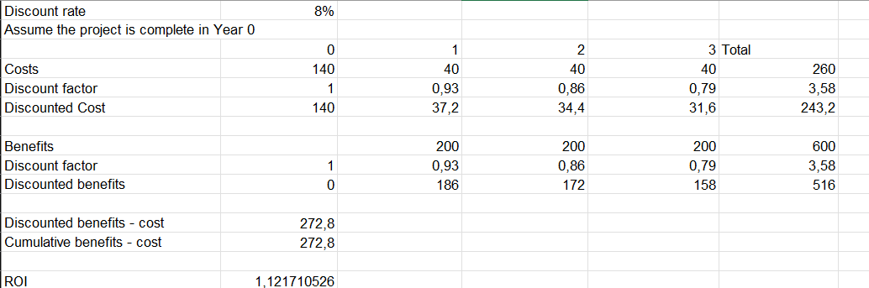
3.
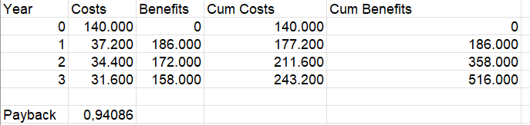
4. 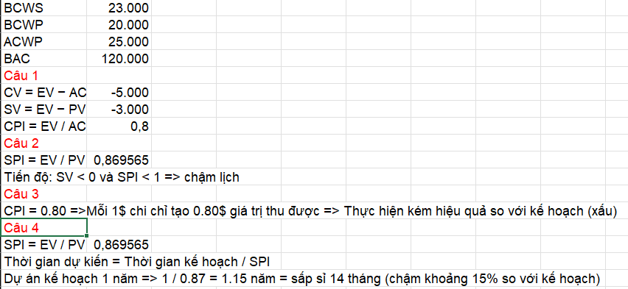
5.
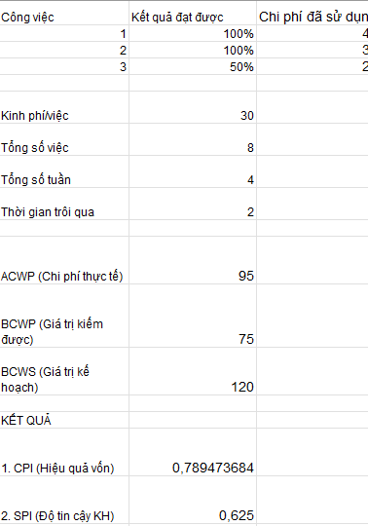
6. 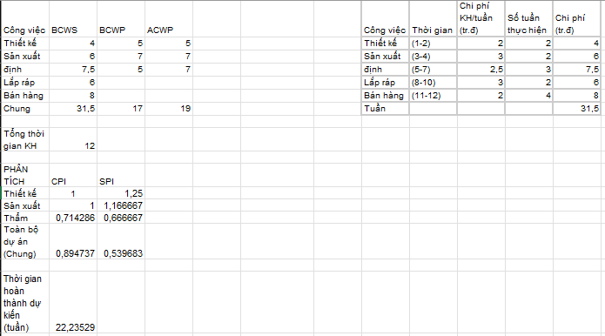
III.
